**Assignment 2: Make Changes and Commit**

1. **Create index.html**:
   * Open the **repository folder** in your code editor.
   * Create a **new file** named **index.html** and add the following code:

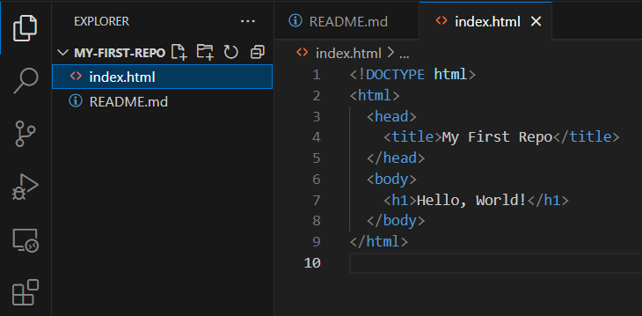

1. **Commit and push**:
   * In **GitHub Desktop**, stage the **index.html** file.  
     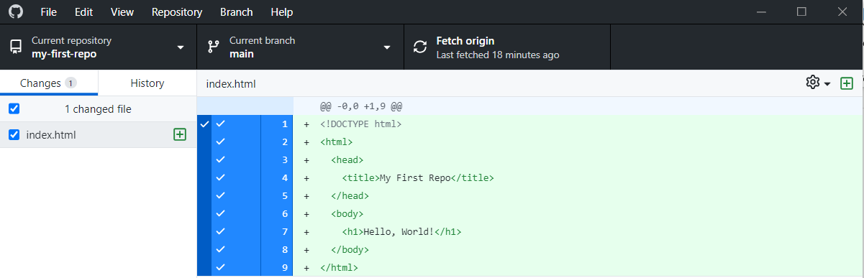
   * Write a **commit message**, e.g., "**Add index.html**."  
     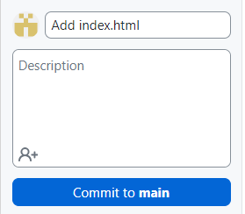
   * Click "**Commit to main**" and then "**Push origin**."  
     